**User Manual**

CIRCLE of INFLUENCE

**January 30, 2022**

To be concerned with what I can do for myself not be bothered with what others can do to prioritize my necessity.

# **Overview**

* A Laravel based web development project based on the idea of "Circle of Influence in Life"

# **Goals**

|  |  |
| --- | --- |
| User Group | Task |
| Admin / Power-User | 1. Login |
| 1. Add Tenant [E.g. – Asia/ Europe/America/such names] |
| 1. Add/Modify/Delete Regular Users Data as per necessary |
| 1. View Regular Users Data [2 possible view point – **Personal** influencers & **Professional** influencers] |
| 1. Download CSV file containing information of Regular Users [2 Separate files – **Personal** influencers & **Professional** influencers] |
| 1. View Graph Chart Based on Regular Users activity |
| Regular Users / Influencers | 1. Register & Login |
| 1. Add Entry – Pick 3 **Personal** Influencers & 3 **Professional** Influencers [Add notes on each influencer] |
| 1. View Activity History |

# **Web Development Requirements:**

Frontend – As per developer

Backend – Laravel

DBMS – MySQL

Type – Fully Responsive & Dynamic

# **User Manual:**

**Installation Guideline (for Local Server)–**

* As the project is built with Laravel & MySQL - so installation of composer, NodeJS, xampp are must.
* After installing xampp, unzip the zip file of the project naming “circle-of-influence” and paste it into “xampp/htdocs/” folder.
* Go to terminal and access the folder naming” circle-of-influence” and hit – “composer update”; it will install all the necessary dependencies.
* Create a database with the name of “circle_of_influence” and hit “php artisan migrate” in the terminal or import the “circle_of_influence.sql” file from dbms, instead of running “php artisan migrate” command.
* And hit “php artisan serve” to run the application.

**Installation Guideline (Live Server)–**

* Place the file into the right place in the server.
* Create a database with the name of “circle_of_influence” import the “circle_of_influence.sql” file from dbms. Or database name can be anything as per your choice but in that case - .env file in the project folder needs to be updated.
* And you are good to go.

**Usage Guideline (General User)–**

* After entering into the url the visitor will see a page like this

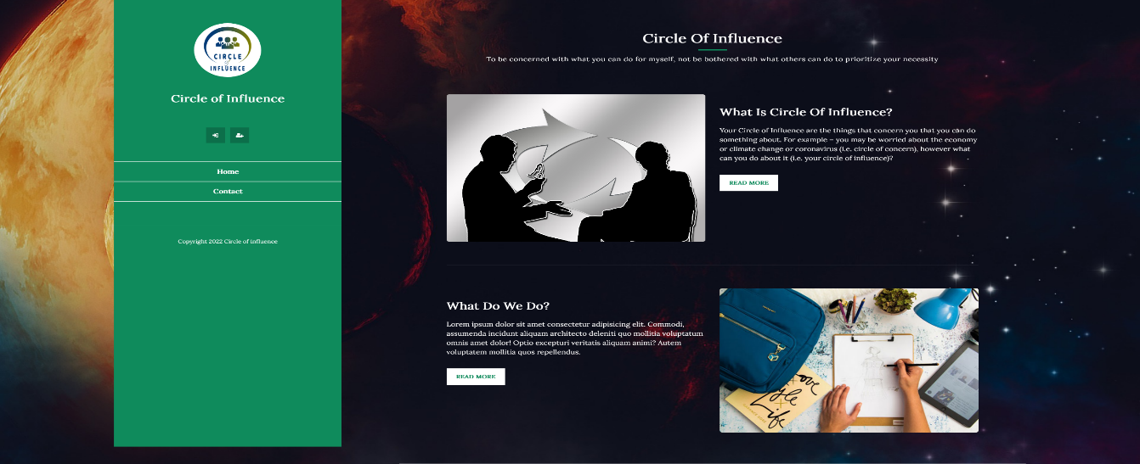

* After that for new user they can register and to complete the process a verification mail like this will be sent to the new user’s email.

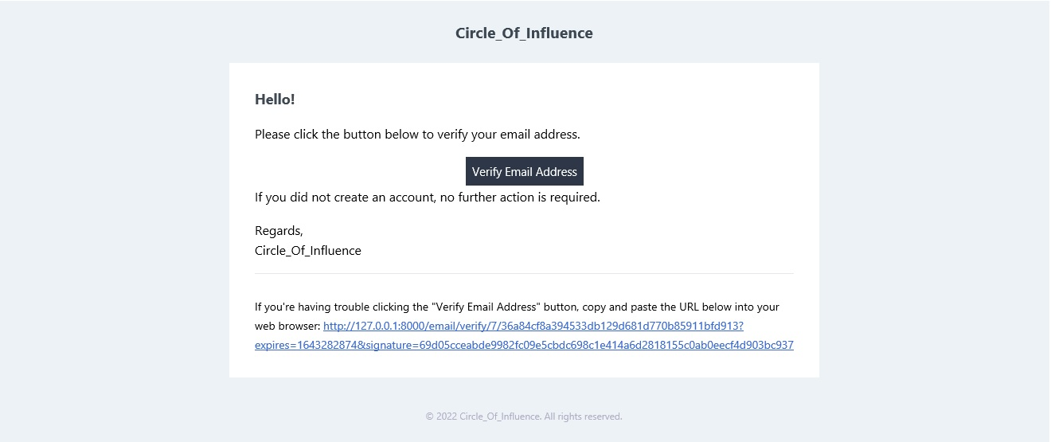

* And for old user they can login using email and password



* A user can update his/her information from edit profile page

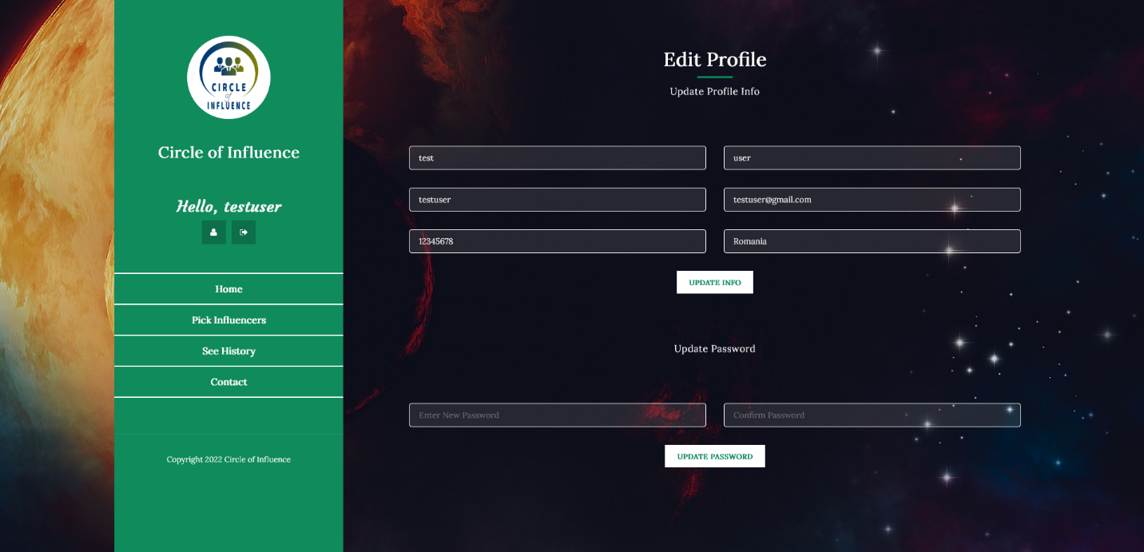

* After logging in the user can go to “Pick Influencers” tab. They will be represented with the following window; here with “Add Row” & “Delete Row” button user can choose their desired number of row data they want to input.
  + They can choose two types of influencers – Personal/Professional
  + They will see a list of users according to their Tenant.
  + After filling in all the necessary info, user will hit “Save” button.

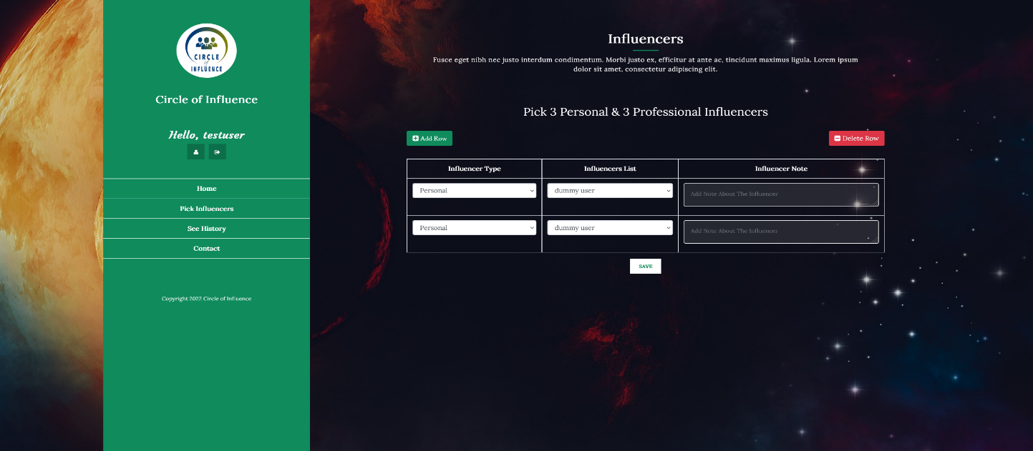

* Then go to “See History” Tab to see his/her previous picks.

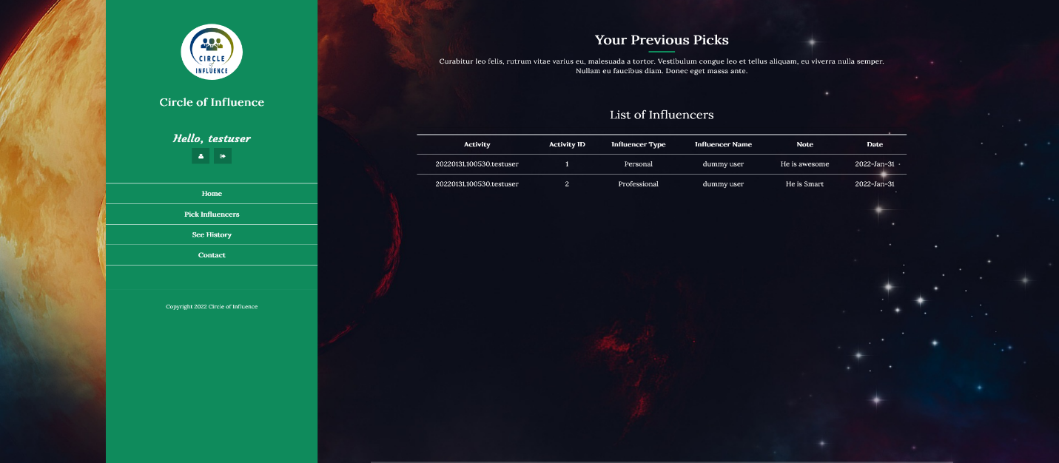

* Registered user can email admin from contact page (if needed)

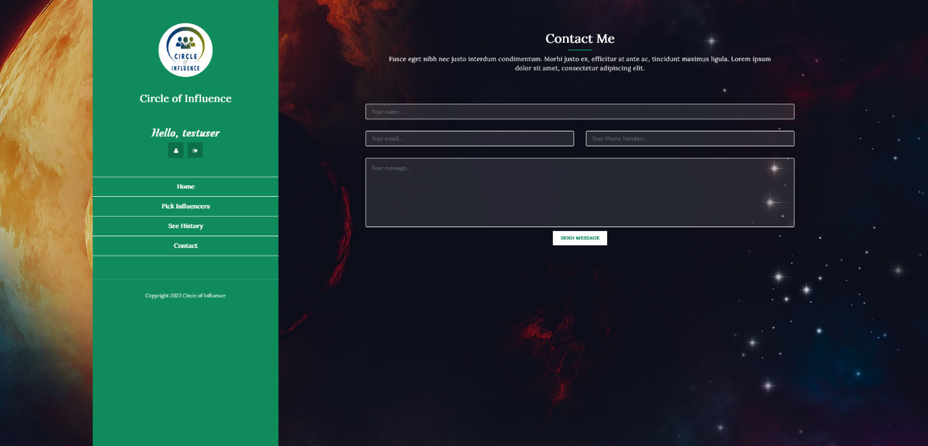

**Usage Guideline (Admin User)–**

* They will enter to the admin panel through the same login page. After logging in they will be represented with a dashboard like this. Here they will see the relational graph between each user and his/her influencers.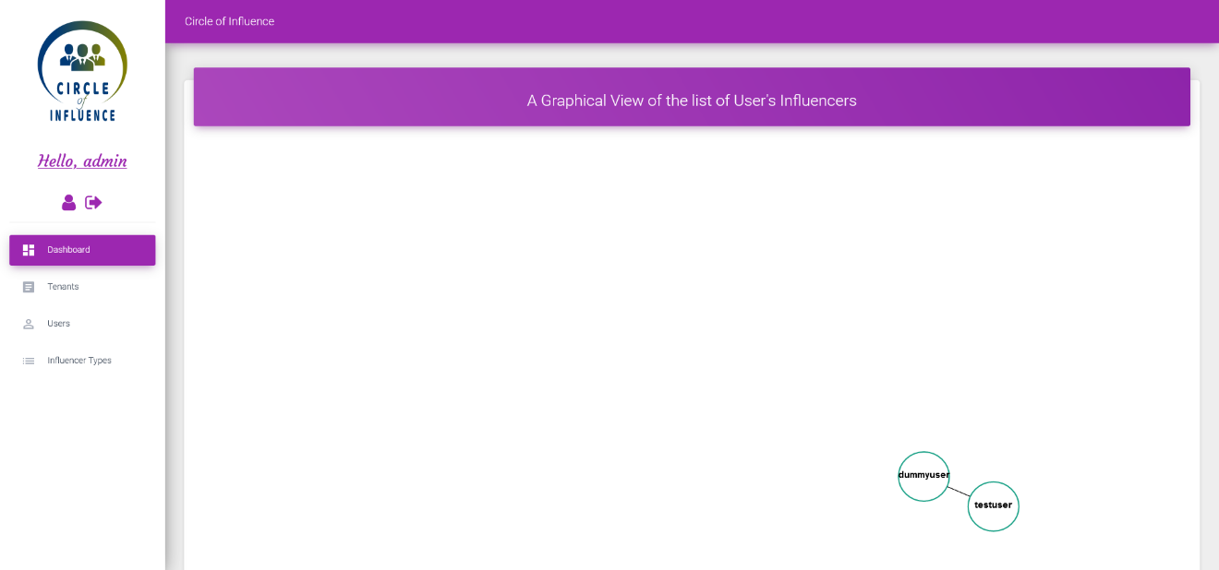
* Entering into the **“Tenant”** tab admin will have the opportunity to **Add / Edit / Delete** and set active inactive status of a Tenant. Similar options will be shown in tab

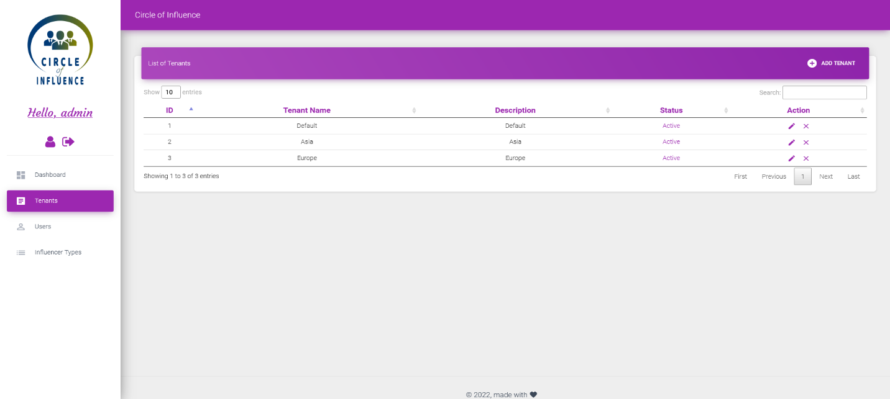

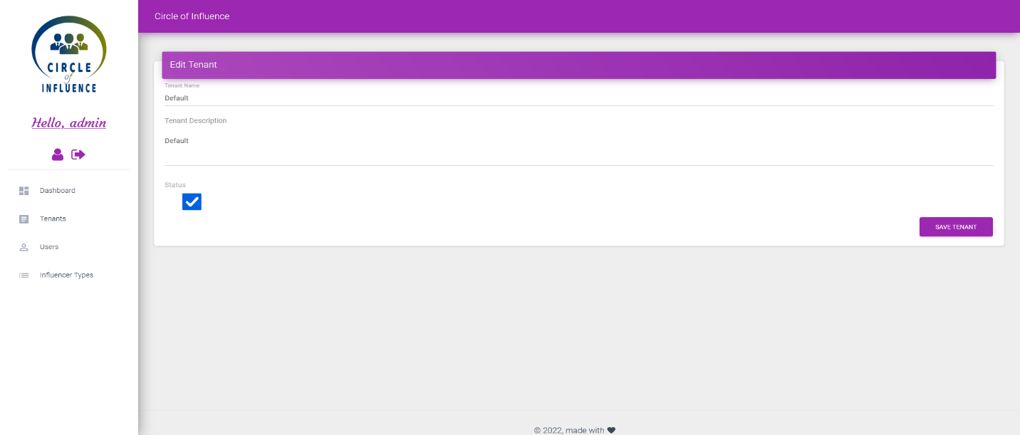

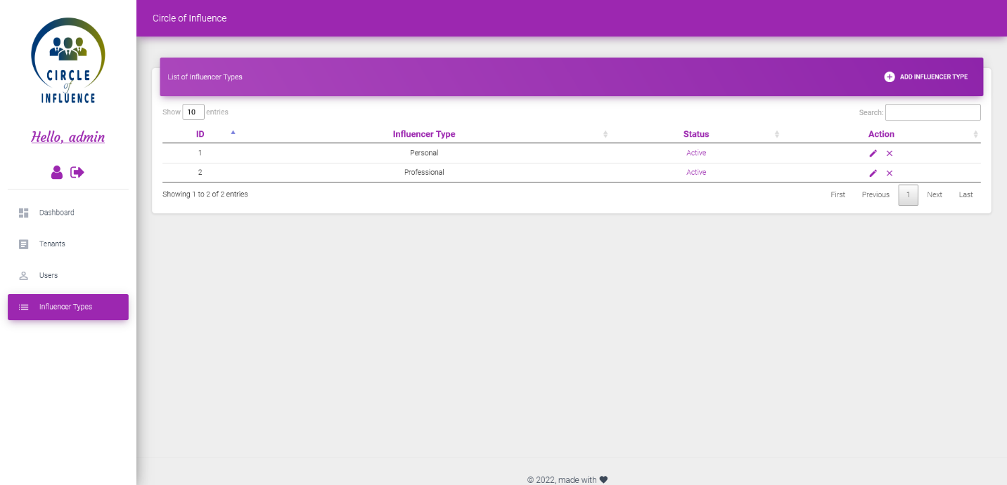

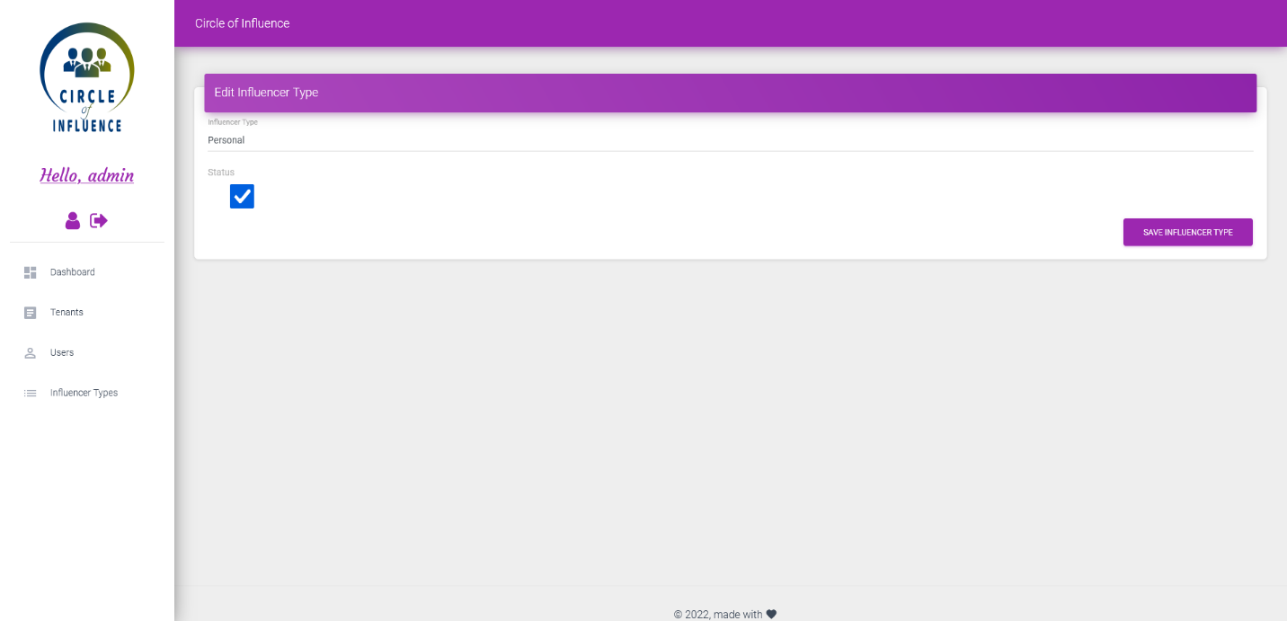

* In User’s Tab admin will see a table with 3 tabular views
  + **Tab1–Users:** will show the list of users registered in the system. Admin can update user’s info. Even assign any user to Admin Role, and select a different tenant as per necessity.

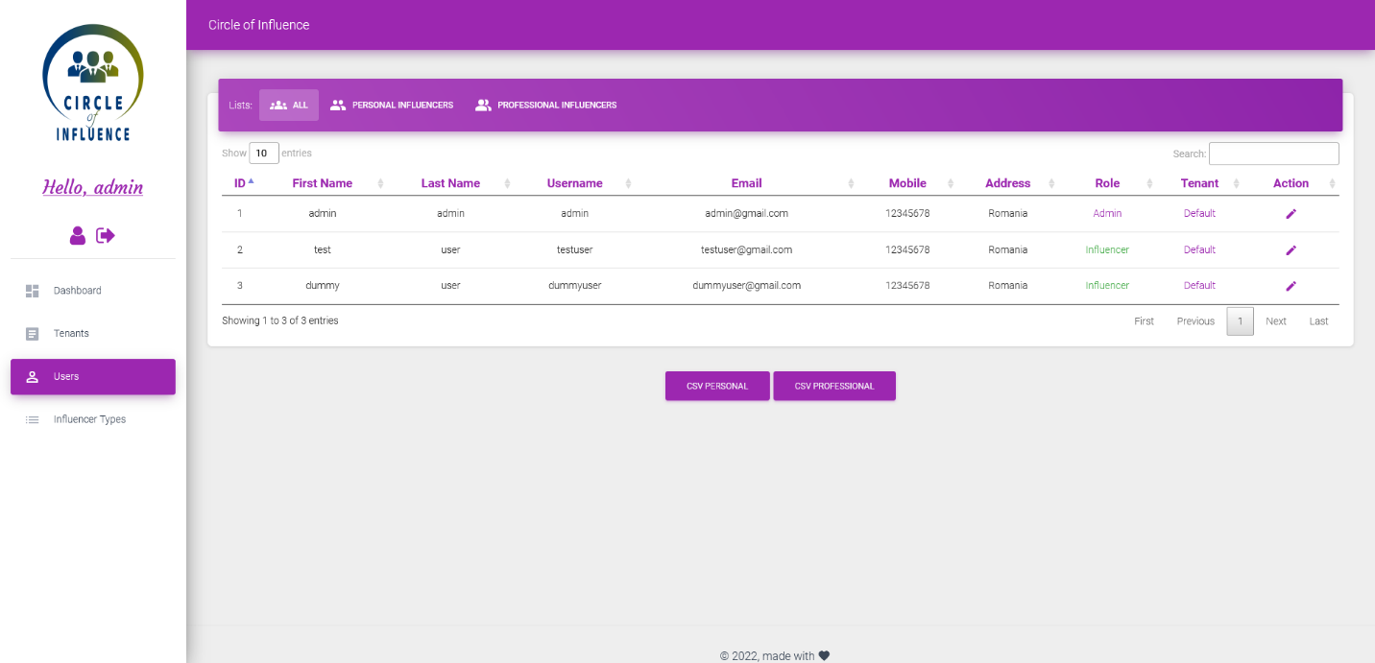

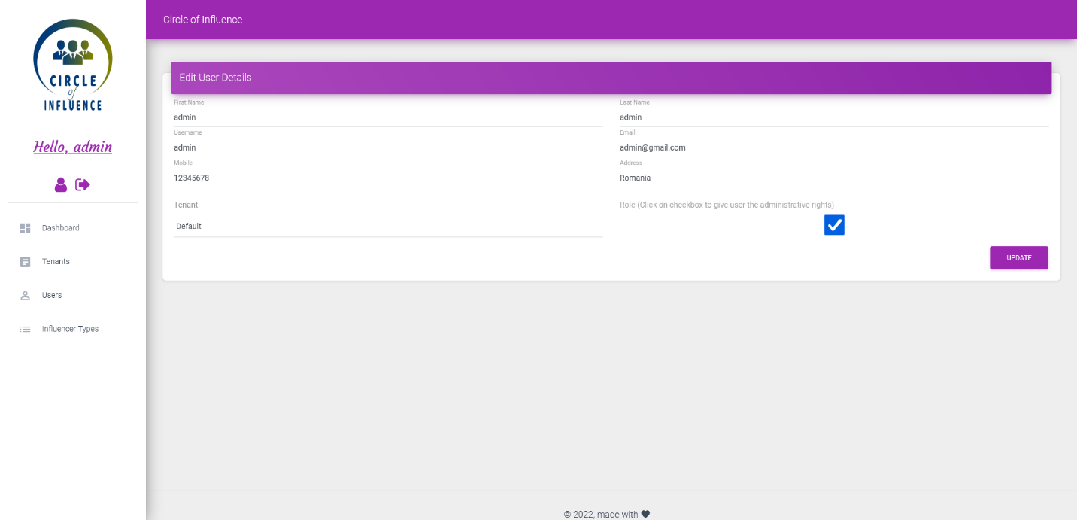

[Note: Name the 1st Tenant “Default” – as any new user registering to this website will be mapped to the first Tenant]

* + **Tab2–Personal Influencers:** will show the list of user’s choice of personal influencers along with several details. By clicking on to the following “CSV Personal” – they list shown in this tab can be downloaded into a csv file
  + **Tab3–Professional Influencers:** will show the list of user’s choice of Professional influencers along with several details. By clicking on to the following “CSV Professional” – they list shown in this tab can be downloaded into a csv file

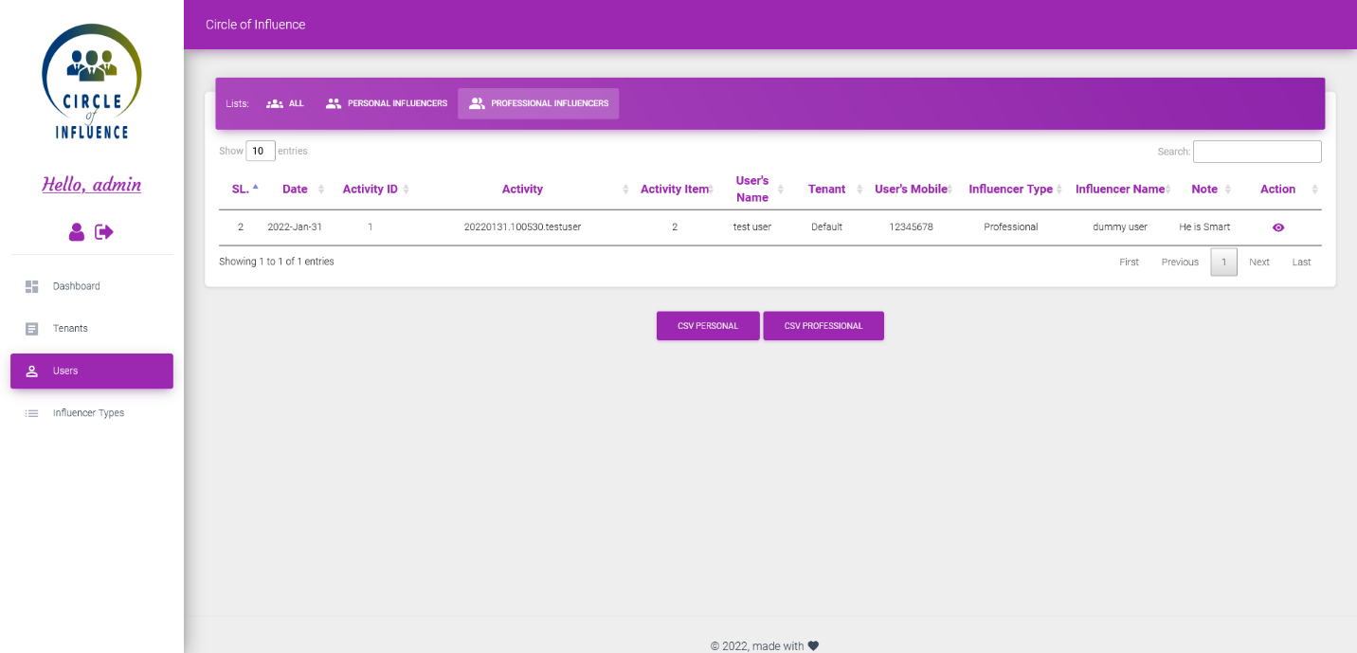

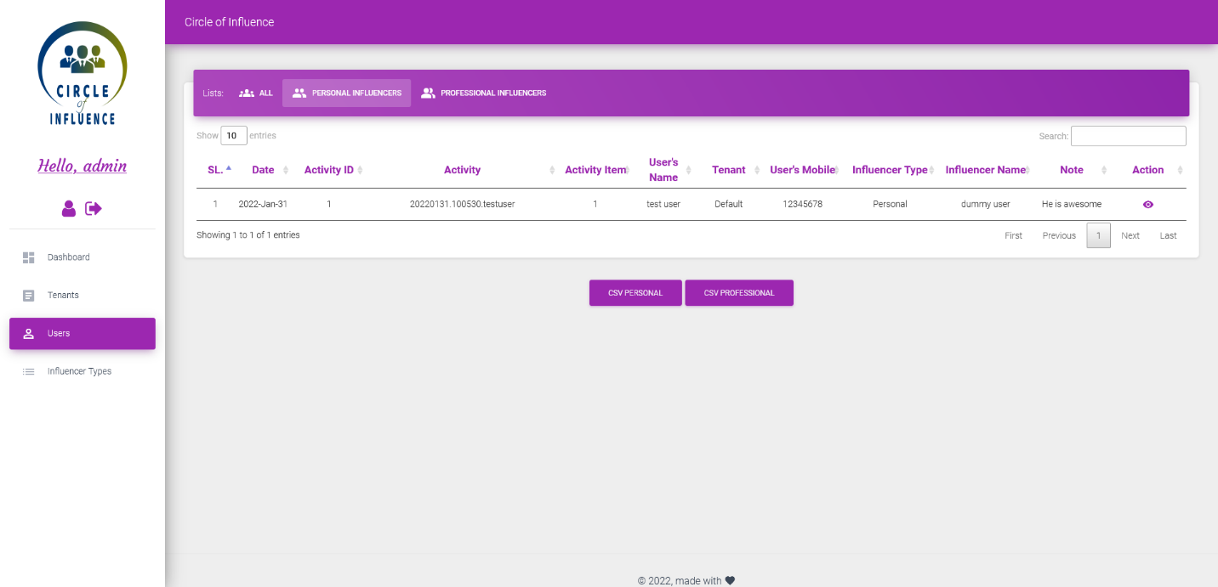

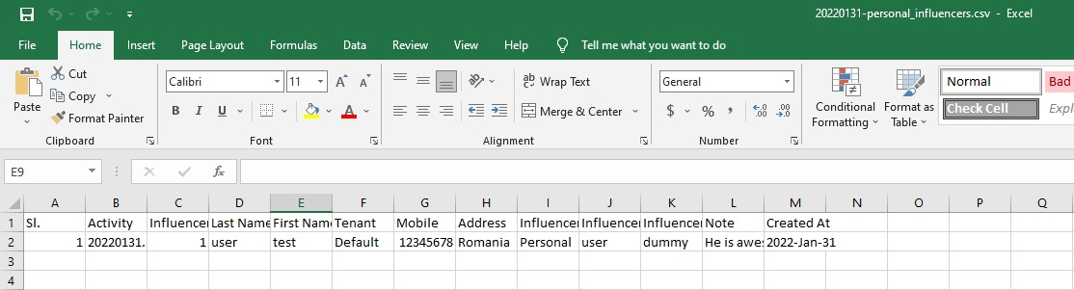

# **Other Important Notes and Guidelines:**

* For registering into the website – A 8 letter password is required.
* Password can be reset by going through “Forgot Your Password?” page.
* Any new user will be mapped to the 1st **Tenant_ID**
* Please change the email address from **“app\Http\Controllers\HomeController.php”** page, otherwise all the mail communication will be sent to the email already given.

For better understanding please see the following images.

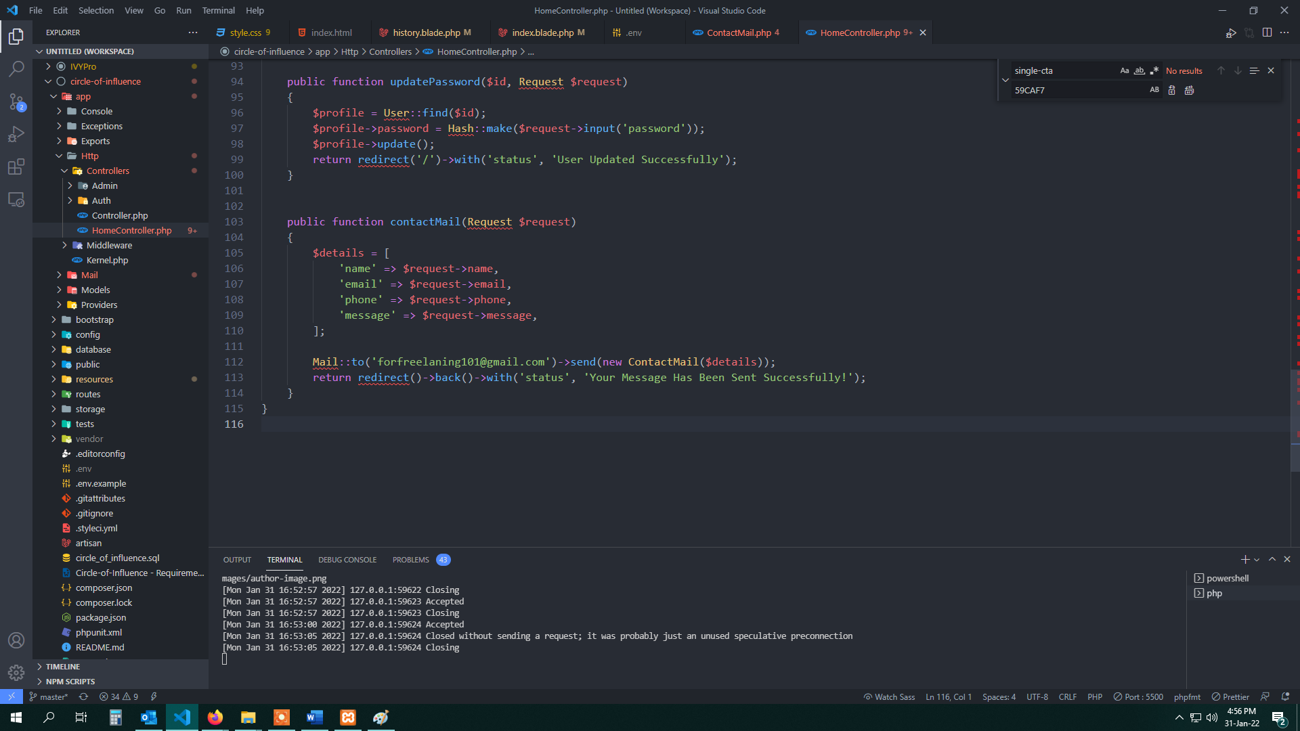

* If existing sql file is imported in the database, you will find 3 users already registered in the users’ table, please use following id and password to get access to all the panels.
  + Admin user - Id: [admin@gmail.com](mailto:admin@gmail.com); Password: admin12345
  + Test User (Not admin) - Id: [testuser@gmail.com](mailto:testuser@gmail.com); Password: 12345678
  + Dummy User (Not admin) - Id: [dummyuser@gmail.com](mailto:dummyuser@gmail.com); Password: 12345678
* Lastly if incase file is project file is generated from github, then run “composer update” after that hit “php artisan key:generate” after that type “copy .env.example .env” in cmd and replace codes of .env file with following.
* APP_NAME=Circle_Of_Influence
* DB_CONNECTION=mysql
* DB_HOST=127.0.0.1
* DB_PORT=3306
* DB_DATABASE=circle_of_influence
* DB_USERNAME=root
* DB_PASSWORD=
* MAIL_MAILER=smtp
* MAIL_HOST=smtp.googlemail.com
* MAIL_PORT=465
* MAIL_USERNAME=forfreelancing101@gmail.com
* MAIL_PASSWORD=Freelancing101
* MAIL_ENCRYPTION=ssl
* MAIL_FROM_ADDRESS=forfreelancing101@gmail.com
* MAIL_FROM_NAME="${APP_NAME}"

***You are all set to go. Good Luck!!***

Regards,

**Md. Nahid Hasan Tamim**

**Email –** [**nahidhtamim@gmail.com**](mailto:nahidhtamim@gmail.com)